**Grower Group Organic Certification**

NOTE - Due to changes within EU and NOP regulations especially for grower group certification, it is important for existing certified grower groups and interested grower groups to understand changes and requirements to become or maintain certified. All major changes are highlighted in **Red** in this document. All the requirements are still relevant and must be followed as per underlying IFOAM Grower Group principles. A certified Grower Group is an organized grouping of primary producers (referred to as members) seeking collective certification and therefore market access with the following member criteria.

Grower Group Certification can be granted only to the entire group based on the group’s internal control system and compliant members. The certification is only granted on a common sales point and therefore individual members must not sell their products individually but only sell organic products **only** through the group’s ICS and common sales point.

Complex farming systems, complex processing and end of chain wholesalers, exporters and traders must be inspected and certified separately and cannot be included in a grower group certification.

Internal Control System (ICS) – Quality management of the group – is an effective documented quality assurance system developed and maintained by the grower group. The ICS must cover all sites and production units affiliated to the group’s internal supply chain. The ICS is combining the group’s compliance and inspection management and its record keeping from farm to export.

ACO annual external inspection and certification mainly verifies the effectiveness of an Internal Control System (ICS) to maintain organic integrity.

**Table of Contents**

Principle of Grower Group Certification – Shared Surveillance 2

Terminology in Organic Certification 2

Group and Member Requirements 3

1. Criteria and Definition 3
2. Responsibilities 4

Group Management 5

1. Quality system management – Internal Control System 5
2. Staff for Group Management 5

Procedures and Documents 7

* 1. ICS Procedure Requirements 7
  2. ICS Document Requirements 8

Inspections 9

1. Internal inspections 9
2. External Inspection 9

Annex 9

Annex I – ACO Organic Integrity Plan – Internal Control System (ICS) 9

Annex II – Typical Course of External inspection 11

Annex III – Process of Grower Group Certification 12

Annex IV – Internal inspection checklist Template 12

Annex V – Relevant International standards 15

# Principle of Grower Group Certification – Shared Surveillance

The smallholder group certification supports trade in certified organic products from their members, without compromising or diluting the strict requirements of international organic standards.

Compared to standard organic certification, **Shared Surveillance** between the certification body and the grower group’s Internal Control System (ICS) has been introduced to manage compliance of each member and therefore the entire group.

The shared surveillance of certification is handled via the restructuring of the certification procedure regarding:

* Record keeping,
* Compliance understanding, and
* Inspections (of the individual farm).

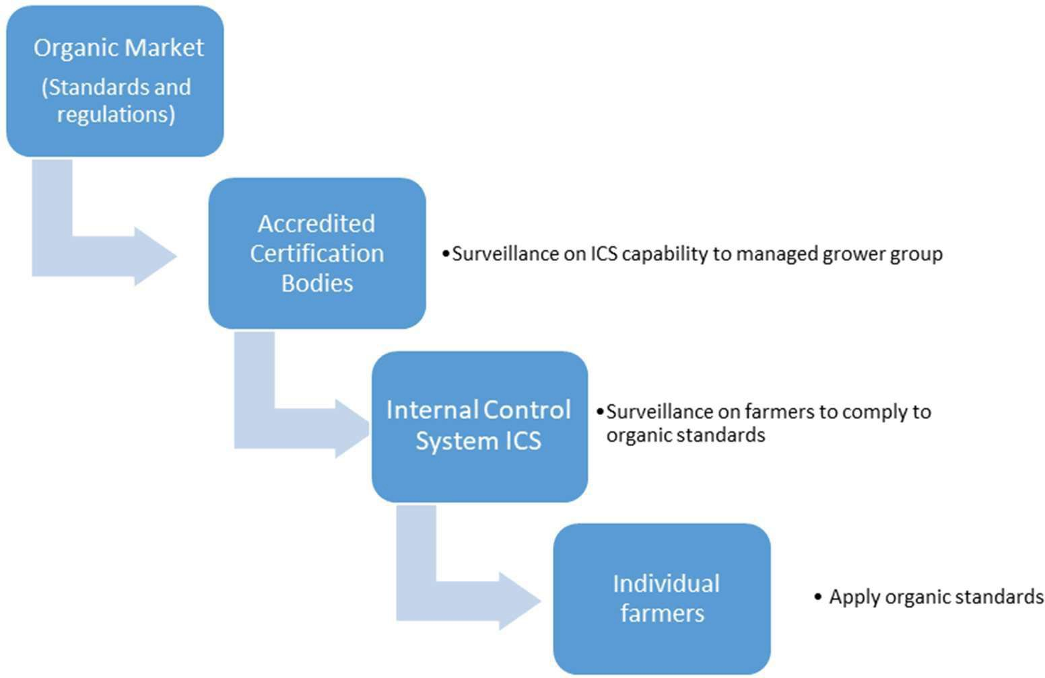

One main obstacle to access certification is primarily caused by a lack of communication and collaboration, leaving shared surveillance a distant goal to reach for. Efficient collaboration and clear understanding of what is required is essential. The Internal Control System (ICS) is a vital partner for the certification body to achieve and maintain certification.

## 

## Terminology in Organic Certification

When a group of smallholder growers becomes certified organic, the group must collaborate and communicate with an administrative third-party entity, an accredited organic certification body. Often the accredited certification bodies are physically absent in the local communities where grower groups are established, and certification requested. Often communication hurdles are emerging because growers are exposed to new terms and procedures that are specific to certification. The understanding and definitions of organic may vary between the certification body and the group. Additionally, the procedures of an Internal Control System ICS may vary from the work procedures of a certification body.

These conditions contribute strongly to the potential non-compliances to organic standards and certification administrative requirements.

Organic versus Certified Organic

For Example: The word organic is commonly used by group members practicing traditional and low input farming, but when used by accredited certification bodies, it involves additional evidence of compliance before a member and its associated grower group can claim certified organic on products.

Some basic certification specific terminology needs to be understood in the same way. See table below:

|  |  |
| --- | --- |
| **Certification terminology** | **Meaning** |
| Organic | A crop, livestock, product, and/or process verified by an accredited third party (certification body) and therefore certified to a specific organic standard/ regulation |
| Certification | A determination made by a certifying body that a production or handling operation conforms with an organic standard or regulation, which is documented by a certificate of organic operation. Certifications are third-party endorsements of systems or products |
| Certification Body (accredited) | A Certification Body when accredited is endorsed by the owner of a standard or regulation to conduct conformity assessment in certification and inspection. An accredited certification body has formal authority to carry out assessment tasks and legally confirm compliance of a system or a product. |
| Inspection/Audit  (internal, external) | A reoccurring visit (at least annual) to check if organic requirements are met on farm, at the processing and handling facility and/or in the office |
| Conventional | NOT verified and approved by a third party. It is not certified and therefore not organic. |
| In conversion/Transition | All new land required for certification must undergo a minimum of 12months conversion and be free of prohibited inputs for at least three years. During this time, members will apply organic principles, but cannot yet sell produce as organic. “In conversion” growers must be under a system of internal ICS inspection and have been subject to sampling by an external inspector. |
| Critical Control Points | Critical aspects to the functioning of the group, from farm level through processing, transporting, etc. that is under responsibility of the group. ICS must have a procedure (risk assessment) to monitor and control them. |
| Noncompliance | Not fulfilling the rules of the organic standards or not having enough evidence that the rules and requirements of an organic standards are met |
| Corrective Action | An action/measure to address and correct the non-compliance identified. This corrective action must be officially submitted by the ICS to the Certification Body for approval. |
| Inputs | Any material used on the farm or used in the processing as an ingredient or processing aid. Fertilizers are an example of inputs. Seeds are inputs as well |
| Prohibited Material | A farm input such as fertilizer or pesticides, an ingredient used to make a product, a processing aid used in the process of making an organic product, and even cleaning products used in areas where organic certified products are handled, stored, processed, which is not allowed under the organic standards/regulations. |
| Field Plan/Management plan | Holistic document (often provided by the certification body) listing all measures, inputs and activities related to the organic standard. From farm to export |
| Production Units | Production units are any site where produce is grown and/or handled post-harvest |

# Group and Member Requirements

## Criteria and Definition

* 1. The grower group must be a legal personality as defined by the country of operation.
  2. The certified legal personality shall be the group as a whole and must agree to be legally bound by the written contract with ACO.
  3. Member criteria
     1. All members of the group are growers. The group can own processing facilities or export themselves.
     2. Exporters/processors cannot hold the certificate of group of operators.
     3. For EU certification, eligible members are:
        1. members of which the individual certification cost represents more than 2% of their annual turnover or standard output of organic production and whose annual turnover of organic production is not more than 25,000 EUR or whose standard output of organic production is not more than 15,000 EUR per year: or
        2. Members who have a combined land holding of maximum:
           1. five hectares (including all plots under common ownership)
           2. 0.5 hectares, in case of greenhouses, or
           3. 15 hectares, exclusively in the case of permanent grassland
           4. Any individual operation identified to be of a size/scale, diversity of activity, and/or separate export streams will be excluded from the grower group certification and assigned an individual certification identity number and process.
        3. The maximum size of a grower group is 2000 members under one legal personality.
           1. Above 2000 members, new legal personalities must be formed, and separate certification applies.
     4. For other certification streams, membership excludes “large farming units”.
  4. The group is certified as a group. Produce from that group can only be sold through the group’s legal entity.
     1. Individual members cannot sell their products as organic outside of the group’s point of sale as organic. Certified sales can only go through the ICS.
  5. Grower members shall practice similar farming systems.
  6. All members or units must:

1. Operate together under the group’s Organic Integrity Plans
2. Work in compliance with the Internal Control System (ICS)
3. Document each step of the group’s supply chain from farm plots to end product.
4. Produce similar products.
5. Be within geographical proximity.
6. Be unified under a training program.
7. Be internally inspected once per calendar year (100% internal inspection for each grower and production unit)
   1. The grower group must have a written contract with each member operator.
   2. Any production unit that processes or consolidates products for more than themselves and one other member must be inspected annually.
   3. Production units must be integrated into the group’s management system.
8. Production units are any site where produce is grown and/or handled post-harvest.
9. The person responsible for each production unit will sign a contract to become a member of the grower group.
   1. Production units must be inspected internally and subject to sampling for external inspection.
   2. Grower Group certification is monitored by annual external inspection.
   3. ICS documentation and correspondence must be in English.
   4. The group and ICS staff must undergo continual competency training, especially on inspectors, on ICS compliance.

## Responsibilities

It is the role of the Internal Control System (ICS) to safeguard the certified status of the entire operation and thus the eligibility of the group as a whole for certification. The Internal Control System (ICS) must

* maintain the **organic integrity** of all production and processing under the group certification,
* demonstrate **documented compliance** with the relevant Standard/s and to this policy and procedure when applying for and/or maintaining certification program/s, and
* function as an **internal training and extension service**, and as the group’s **internal verification system**.

The **internal verification system** is based on **internal onsite inspections** of all involved members and production units. The Internal Control System is a continuous cycle of capacity building, monitoring, assessment/approval, and corrective measures. The implementation is then ensured again by training and monitoring.

* 1. Grower Group certification is based on the implementation and maintenance of an organisational management plan which includes a framework for an internal control system ICS covering all growers and production units.
  2. The ICS must protect the organic integrity by:
     1. Verifying compliance for each grower and production unit
     2. Managing 100% of internal inspections of all growers and production units to verify compliance on behalf of the certification body (Shared Surveillance)
     3. Report and act upon noncompliance within the group according to ICS procedures:
        + If the ICS is identified as not having detected or acted on an internal noncompliance, a separate noncompliance must be raised, one for the affected group and one for the ICS.
        + If the ICS fails to act on noncompliance issued, suspension or decertification may be applied to the group.
        + Willful violation may result in decertification.
  3. If during internal inspection any member or production unit that willfully violates the organic standards shall not be permitted to re-join the group until ACO approves measures taken to ensure that the violation is not repeated.
  4. Where the ICS has failed to detect or act on a noncompliance committed by a group member, ACO will separately raise a noncompliance for the ICS and apply sanctions to the group as a whole, including, in case of serious deficiencies, the withdrawal of certification of the entire village where the noncompliance occurred.

#### Note: It is especially important that the grower group and its internal control system have sufficient financial security and adequate technical capabilities and infrastructure.

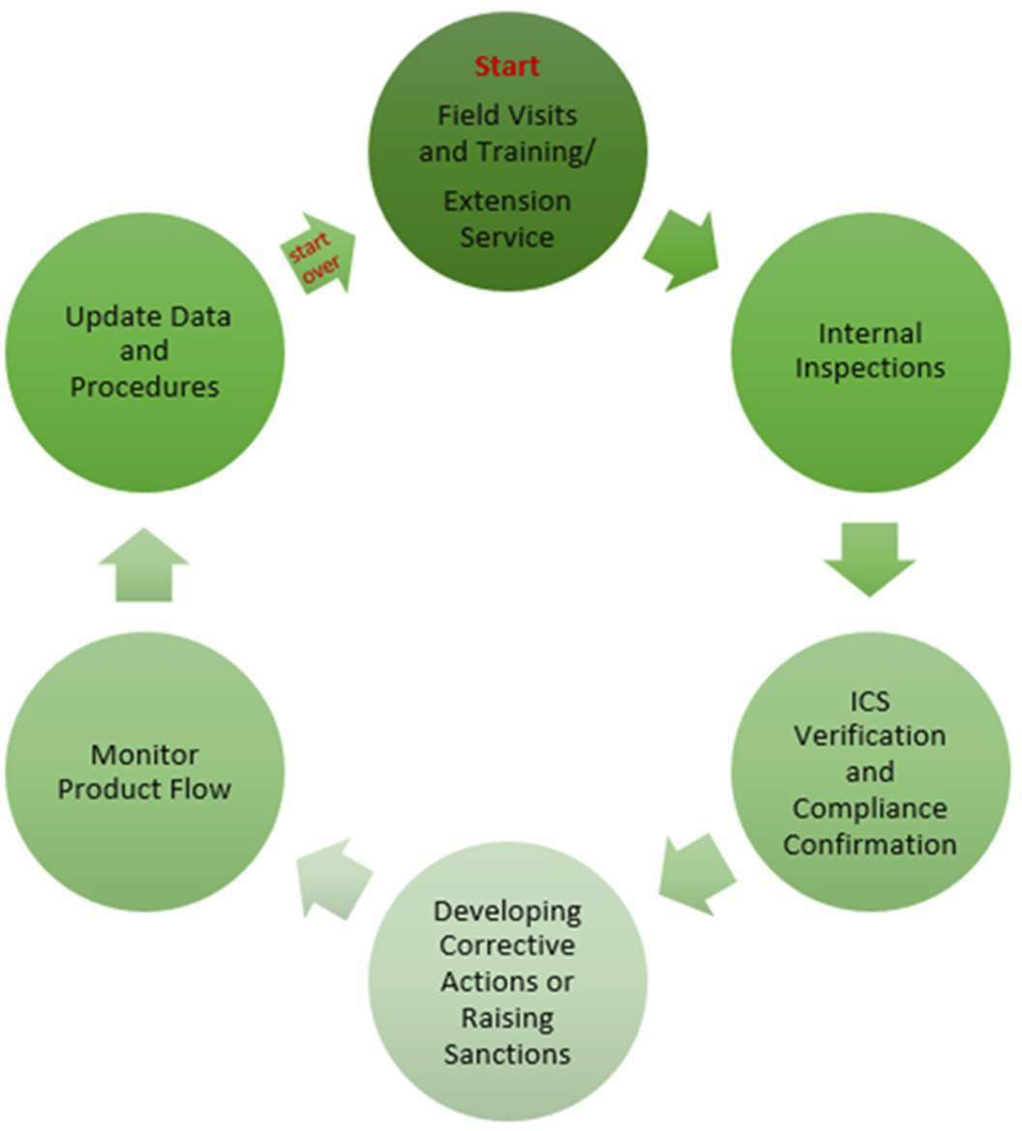

# Group Management

## Quality system management – Internal Control System

The ICS structure and content must be confirmed in an ICS MANUAL covering at least.

* 1. Organizational Structure including staff.
  2. Group’s supply chain (flow chart) from plot to end product including all production units.
  3. ICS Procedures
  4. ICS documentation
  5. Training
  6. Detailed Grower Data Base

## Staff for Group Management

The staff is the intermediary group´s representative for the certification body and will act as the coordinator of the group and is responsible for the group’s compliance.

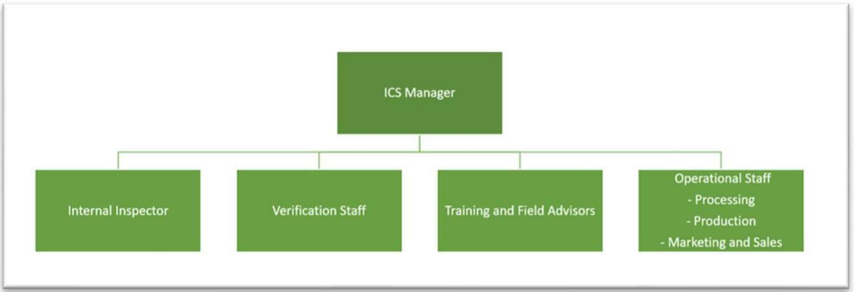

* 1. The group must have an organizational chart defining sufficient staff and their roles and responsibilities.
  2. All staff must show competencies for the tasks and responsibilities – **as per table 1.**
  3. All ICS staff must participate in ongoing training for ICS and standard requirements.
  4. ICS shall develop a performance review for each ICS staff member including witness audits and training or inspectors.
  5. Requirements for ICS personnel shall include:

A contract specifying employment parameters including a clause that defines staff member rights and responsibilities in reporting noncompliance.

### **Table 1 Tasks and responsibilities**

|  |  |  |
| --- | --- | --- |
| **Categories** | **Tasks** | **Requirements** |
| Manager | * Perform the overall management functions and supervision of all staff roles. * Define and implement all ICS procedures. * Ensure that each group member is inspected and verified at least once a year. * Is the contact person for the Certification Body, including coordination of External inspection. * Report noncompliance and corrective actions to the Certification Body as defined below. * Any suspicion of major and critical non- compliance * Any suspension or withdrawal of a member or a production unit or premises, including purchase and collection centers, from the group. * Any prohibition of the placing on the market of a product as organic or in-conversion, including the name of the member or members concerned, the relevant quantities and lot identification. | * Fluency in the local language * Reading, writing, and speaking skills in English for managers, or capacity for adequate translation for other staff. * Understanding of the applicable all relevant organic standards * Familiarity with the local agricultural production * Understanding of relevant critical control points in the supply chain. * Understanding of the ICS procedures and regulations * Current declaration of conflicts of interest and confidentiality statements for all ICS staff |
| Internal Inspectors | * Qualified internal inspectors carry out the internal inspection based on ICS procedure and checklist. * Internal inspectors inspect every grower group. * member annually, including all production units and unregistered plots. * No consulting and extension services will be provided by the internal inspector during inspection.   Report noncompliance to ICS |
| Operational Staff | * Verify the internal inspection reports and determine the group’s internal decision on whether a group member is approved. * Records decisions on the group database (compliance or noncompliance of each grower or production unit). Implementing ICS procedures and documents including data and compliance   management for traceability on the entire groups supply chain |

# 5. Procedures and Documents

The ICS Manual includes procedures and documents of all certified and uncertified activities of the group. It defines the record system and compliance procedures of all members, production unit. All procedures and documents must be kept up to date and resubmitted to ACO for risk assessment prior to annual audit.

## ICS Procedure Requirements

|  |  |  |
| --- | --- | --- |
|  | **Procedure** | **Content** |
| 5.1 | Risk Management | procedure for assessing and managing risks associated with the group, including a documented set of critical control points for all activities of the operation |
| 5.2 | Compliance Decision and Noncompliance and Sanction | procedure which documents how decisions are made, particularly in relation to evaluating the group’s compliance to the Standard and setting noncompliance Additional it should define the management and recording of noncompliance and resulting sanctions, including a procedure for ensuring that the Certification Body is notified of noncompliance as defined below. Actions on noncompliance and violations per grower, subgroup, or group are to ensure organic product integrity.   * Any suspicion of major and critical non-compliance * Any suspension or withdrawal of a member or a production unit or premises, including purchase and collection centers, from the group. * Any prohibition of the placing on the market of a product as organic or in-conversion, including the name of the member or members concerned, the relevant quantities and lot identification. |
| 5.3 | Including new growers | New growers may be added to a group by submission of contract and map, internal inspection, verification of organic compliance, addition to grower list (the Grower Group Data Form submitted to ACO), and subject to sampling for external inspection. Growers will be subject to a minimum 12-month conversion period as  defined above. |
| 5.4 | Internal inspection procedure | Managing annual internal and follow-up inspections for all group members, as per Internal Checklist Template. New members must be inspected prior to entry into the group. |
| 5.5 | Conflict of interest | Identify and manage conflicts of interest within the group |
| 5.6 | External inspection procedure | Managing annual external sample inspections including witness inspections |
| 5.7 | Training | Regular and ongoing training and competency building of staff and grower, including position-specific competency development and training |
| 5.8 | Traceability | Entire supply chain traceability from certified and non-certified plots to end product including all production units and Critical Control Points. |
| 5.9 | Input | Identifying the need for inputs (seeds, fertilizers, tools, etc.) and the approval process for supply to individual growers, subgroups, or entire groups. Inputs must be consistent with the approved Organic Farm Plan for the group. |

## 

## ICS Document Requirements

|  |  |  |
| --- | --- | --- |
|  | **Document** | **Content** |
| 5.10 | Organic Integrity Plans | Production and processing within certification scope of group against all relevant standards including Organic Integrity Plan – Internal Control System |
| 5.11 | Staff documents | * Conflict of Interest forms * Confidentiality agreement * Contracts * Competency profiles of internal inspectors and staff |
| 5.12 | Grower documents | * Grower entry contract including registration data of growers such as Land and input history and Land and yield data. The contract also must confirm the operator’s understanding and compliance with the relevant Standard, outlining the consequences of non-compliance and sanctions, permitting internal ICS and external ACO inspections. requiring growers to report any changes that might affect the operation’s compliance. The grower should have received a copy of the contract they signed. * Maps of individual grower plots, production units, and an overview map, including geolocation coordinates * Flowcharts of supply chain |
| 5.13 | Grower Data (to be kept in the ACO Grower Group Data Form) | * Names of all group members * All production units including address and contact person. * identification numbers for each grower * Date when each grower/unit joined group (start of conversion period) * Hectares certified and uncertified. * Certification status per plot/area (In conversion, Organic, Suspended) * Nonregistered plots including hectares owned by grower/family. * Crops produced/processed. * Yield (potential) * Harvest/collection * Sale * Date of Internal inspection * Name of Internal inspector * Compliance result of last internal inspection * Date of External inspection * Compliance result of last external inspection compliance * Risk based additional inspection needed |
| 5.14 | Internal inspection checklist  Template in Annex | * Referring to all organic standards and regulation requirements the group is certified too. * Covering all activities including non-organic of each grower and production unit * Listing non-compliances |
| 5.15 | Others | * Catalogue of Measure for Corrective actions and Noncompliance register for all growers and production units * Traceability documentation system * Compliance and sanction records |

# Inspections

## Internal inspections

* 1. Internal inspectors must comply with the ICS staff requirements and must have competencies in auditing. Agricultural knowledge and group systems
  2. Internal inspectors shall carry out at least one annual inspection visit to each grower including visits to all fields and facilities associated with that member including non-registered plots.
  3. Internal inspectors shall identify and inspect grower and production unit specific critical control points.
  4. Internal inspections must document all non-compliances and verification of corrective actions.
  5. The ICS must communicate in writing with individual group members regarding all irregularities and minor non-compliances found, including the corrective actions imposed with the agreed time for completion.
  6. The ICS must maintain records of all non-compliances detected in the group including the agreed time for completion of corrective actions. Instances of non-compliance by a group member must be reported.

## External Inspection

* 1. Annual external inspections of the entire grower group supply chain must verify.
     1. The group’s organic management system plan
     2. ICS implementation and compliance
     3. ICS effectiveness in protecting organic product integrity.
  2. Prior to annual external inspection:
     1. The ICS must submit current Management Plans and updated grower group database for document review and risk assessment.
     2. For EU certification, the minimum number of growers required for inspection will be 5% of the group, chosen randomly, with additional growers selected based on risk. For other programs, assessment will be based on the square root of the total number in the group, multiplied by a factor determined by risk assessment.
     3. Sampling of produce (or soil, in the case of unavailability of produce for sampling) for at least 2% of group members for EU certified groups. Cost for sampling to be incurred by the operator.
     4. External inspection course
        1. Opening meeting
        2. ICS Inspection includes implementation of all procedures and documentations.
        3. ICS 100% annual internal inspections verification
        4. A combination of random and risk-based selection of members to be inspected by external auditor.
        5. Witness audit(s) of an internal inspection(s)
        6. Exit meeting.

# Annexes

## Annex I – ACO Integrity Plan – Internal Control System (ICS)

To be completed together with ACO Organic Integrity Plans – Crops and Pasture and Organic Integrity plan – Processing and Handling.

|  |  |  |
| --- | --- | --- |
| **ICS OMP and Checklist for doc review and audit** | **Completed by:** | **Date Completed:** |
| **Category** | **Question** | **Answer ICS Manager** |
| Entity | Is the group a legal personality? Describe and attach evidence |  |
| Entity | Does the group as a joined point of sales only for organic? attach evidence |  |
| Entity | Is the groups management and system available in English? |  |
| Members | Are all members Farmers? If not, give details on non-farmer members |  |
| Members | Are all members eligible to be members? attach evidence Note that managed and owned land not certified must also be considered for member compliance |  |
| Members | Does the group have maximum 2000 members? |  |
| Define the geographical proximity criteria or radius of the group’s members and any production units. | All members are required to be in the same defined geographic proximity of one another. |  |
| Members | Is the Grower Group Data Form current and completed? Please attach |  |
| Farming System | Do all members practice similar farming systems and operator under groups approved integrity plans and ICS procedures? Attach ACO completed Plan templates and submit comprehensive Input Register for all inputs used by group managed through ICS. |  |
| Farming System | Do all members operate on a common input regime? Have prohibited inputs been used by members? |  |
| Production Units | What production units exist within the grower group and are they compliant? Describe and submit list (production units are for example all clusters, post-harvest handling sites, facilities, transport etc.)  A detailed **flow chart including ALL production units** must be submitted |  |
| Production Units | Are all production units listed in Grower Group Data Form including annual inspection? |  |
| ICS Staff | Does the group have an Organizational chart defining sufficient staff and their roles and responsibilities? Attach org chart and List of ICS staff and their competency |  |
| ICS Staff | Does the ICS staff have the right capacity and competency to ensure compliance for the entire group? Are there capacity and competency gaps? |  |
| ICS Staff | Are all ICS staff fulfilling their responsibilities? |  |
| ICS Procedures | Does the ICS have comprehensive and current procedures? List missing or inadequate procedures or implementation of procedures. |  |
| ICS Training | Has there been training for ICS staff and farmers during this audit period? Is this compliant to Training policy? Please list content and participants |  |
| ICS Internal Inspections | Did the ICS conduct 100% internal inspection of all members and production unit? Have all inspections been recorded in Grower Group Data Form? Have sanctions and noncompliance been recorded in the noncompliance register and communicated to ICS manager and ACO? |  |
| ICS Documents | Are all relevant staff documents compliant and maintained? Attach example |  |
| ICS Documents | Are all relevant member documents compliant and maintained? Attach example |  |
| ICS Documents | Are overview and details member maps compliant and maintained? |  |
| Traceability and mass balance | Is the documentation system compliant to ensure full mass balance within the group and product traceability from each member to collective sales point? describe process and submit documents. Auditors to conduct a full traceability exercise to proof submitted system. |  |
| ICS Documents | Is the Internal Checklist adequate to reflect all current standards and ICS requirements. |  |
| External audit | Follow up on last External Audit - have you implemented CAR and trained ICS staff and members on last external audit outcome? |  |

## 

## Annex II – Typical Course of External inspection

|  |  |  |
| --- | --- | --- |
| 1 | Risk assessment and document review | The ICS submits up to date management plans and grower data to Certifier.  Certifier will conduct a Risk assessment and document review.  During the risk assessment the minimum number of externally inspected growers (statistic and judgment/risk sampling).  The certified will identified that all producing units are going to be inspected |
| 2 | Opening meeting | Inspector discusses with ICS manager the inspection |
| 3 | ICS office inspection | Review and assess all ICS documents.   * Grower group List, procedures, and farm files * Check and verify if procedures are applied in daily management of ICS, e.g., data collection, sanction |
| 4 | Member field inspection | The number of members as per risk assessment (Annex 5) provided by certification officer must be inspected.  Farm interviews and field assessment shall be done at each farm.  Note: members being inspected by external inspector must vary and cannot be the same members every year. Especially remote and/or high-risk members must be considered |
| 5 | Witness Audits | The external inspector observes internal inspector’s performance |
| 6 | Production units Processing/handling site inspection | All the handling and processing areas must be inspected individually, and a report must be completed by the external inspector |
| 7 | ICS office inspection | Audit and verification of the information collected during inspection of sample group members, witness audits, interviews, inspection of product flow from group member to storage and handling facility |
| 8 | Exit interview | To finalize the external inspection, the ICS must organize a final meeting with the external inspector and relevant ICS staff. During this meeting all open questions, concerns, and non-compliances identified must be discussed.  The ICS must sign confirmation that the non-compliance raised by the external inspector has been recognized.  Note: finale compliance decision will be made at the certification body office. |
| 9 | Data update | ICS manager is responsible for recording in grower group data (Grower Group Data Form or similar) which members have been externally inspected. |
| 10 | External Inspection report | External inspector writes a complete inspection report as per  certification body‘s set up which will cover compliance for all certification programs. |

## Annex III – Process of Grower Group Certification

|  |  |  |  |
| --- | --- | --- | --- |
| **No.** | **Step** | **Responsibility** | **Actions to be taken** |
| 1 | Get organised | ICS | * Form group structure * Develop Organic Integrity Plans   + Internal Control System ICS   + Crops and pasture   + Processing and Handling * Develop all necessary procedures and documents. * complete documents including grower data form. * On farm inspections with all members including contracts countersigned |
| 2 | Application for certification | ICS | * Contact Certification Body * Disclose market and group structure (number of members, production, and locations) * Complete relevant documents |
| 3 | Review of documents by certifier | CB | * Review of compliance of Organic Manual and Integrity Plans * Arrange and organize an external inspection: collaboration of ICS and Certification body |
| 4 | External initial inspection | CB | -Inspector from Certification Body inspects ICS and a selection of members based on Certification body’s Risk Assessment |
|  | Certification decision | CB | * Certification Body inspector-submitted inspection report * Certification Body review documents and the report * Certification body communicates with ICS if information is missing or unclear to assess compliance. * Certification granted or denied. |
| 6 | Conduct 100%  Internal inspections | ICS | During the year of certification  -ICS conducts 100% of onsite inspections and records and documents all steps required for compliance information |
| 7 | Updated ICS Manual | ICS | -ICS submits updated grower group information (including the Grower Group Data Form) and comprehensive organic integrity plans to certification body prior to 12 months re-inspection |
| 8 | Review | CB | -Certification body reviews new and updated information |
| 9 | External inspection | CB | -Annual re-inspection for re-certification organized |
| 10 | Re-certification | CB | * Review of inspection report by the Certification Body * Non-compliances identified and raised as necessary. * Certification re-issued with updated certificate. * Return to step 6 for continuation of certification |

## Annex IV – Internal inspection checklist Template

Please ask the responsible farmer or representative the questions and record the answers in detail. Please do not answer any question for them and do not change the answers given.

Please complete and maintain in English or Bilingual. All operational documents must be at least in English for ACO to verify the data and statements.

|  |  |
| --- | --- |
| Inspector Name |  |
| Internal Inspection date |  |
| Member Name |  |
| Organic ID |  |
| Farming family members on this land |  |
| Location of farm |  |
| Does the member have a valid contract with ICS? |  |
| What are the standards that the member is inspected for? List all e.g., NOP, EU, IFOAM, ACOS etc. |  |
| Last training for member (date and content)? |  |
| Date member entered the ICS. |  |
| How many plots do you own and what are the hectares per plot? Including non-certified |  |
| Certification status ((In-conversion, Organic, conventional) |  |
| Crops/Commodities grown under ICS |  |
| If perennial: How many trees per hectare? |  |
| What is the potential yield? What units? |  |
| For the Inspector: Is the farm map you got from the office correct and shows all details |  |
| **Farm management** |  |
| Do you understand the **Organic requirements**? |  |
| Do you **record** all farm activities (such as inputs, harvest, etc.?)  If not, how is it done? |  |
| Do you have any **prohibited inputs** on his farm, in the house or in easy access? |  |
| Are there any **external or internal risks** of contamination or commingling with non- certified products? |  |
| Is there a risk of contamination from neighboring conventional plots? |  |
| What is the infrastructure in risk of contamination on each farm including public infrastructure (power, channels, streets) |  |
| **Hazardous waste** |  |
| Is the farm kept free of hazardous waste? |  |
| What do you do with the farm waste? |  |
| **Parallel Production** |  |
| Do you or your family have **uncertified fields**? |  |
| If yes, how is risk of mixing managed? |  |
| Do you or your family **supply** products to others? |  |
| **Inputs** |  |
| What **inputs** were used during the last 12 months (list all including planting material)? |  |
| For initial entry of a member:  What are the **inputs** used for the last 36 months? |  |
| Do you **record the inputs**? If not, why? |  |
| Do you use **inputs** not organized by the group? |  |
| Do you use compost and/or mulch If **compost** is used, how it is made? |  |
| Do you irrigate on the farm? |  |
| **Biodiversity** |  |
| Do you **proactively look after** soil, water, air, and biodiversity? |  |
| Is there sufficient biodiversity |  |
| Are there lands at risk of soil erosion or land already eroded on your farm? |  |
| What is done to **improve** local biodiversity? |  |
| Do you clear forests or trees to expand your farm |  |
| Do you have any introduced species on your farm |  |
| Do you hunt or collect rare or endangered species |  |
| **Soil management and cultivation** |  |
| Do you maintain and improve the **soil health?** How? |  |
| Are any **restricted methods** used (such as burning?) |  |
| **Weeds, Pest, and Diseases** |  |
| What are the strategies to monitor and manage **problem pest, disease, and weeds?**  Are there any pests or diseases present on your farm |  |
| Are any **inputs** used if problems arise? If yes list all. Did ICS approve the use? |  |
| Do you have animals and how do they put a risk to organic integrity |  |
| **Handling and Records** |  |
| How are products **harvested**?  Any contamination risk or mixing with conventional products?  List tools and containers used. |  |
| How is **harvest recorded**? |  |
| Are products **processed** on farm (drying, washing, cutting, etc.?) List tools and containers used.  Any contamination risk or mixing with conventional products? |  |
| How are products **transported** to the first handling depot?  Any contamination risk or mixing with conventional products? |  |
| How is **transport recorded**? |  |
| **Compliance Assessment from inspector** |  |
| Did the farmer/farmer family comply with the organic standards? |  |
| Does the farmer have any previous noncompliance? If yes have they been closed out. |  |
| Are there any risks to organic integrity |  |
| What is the overall risk of the farmer (high, medium, low)? Explain. |  |

**MEMBERS SIGNATURE DATE**

**I declare that I have visited the farm and interviewed the grower and the information provided by me is true and correct.**

|  |  |
| --- | --- |
| **Inspector Name** |  |
| **Signature** |  |
| **Date** |  |

## Annex V – Relevant International standards

#### USDA NOP

USDA NOP 205 including group of operation requirements under NOP 205

https://[www.ecfr.gov/current/title-7/subtitle-B/chapter-I/subchapter-M/part-205?toc=1](http://www.ecfr.gov/current/title-7/subtitle-B/chapter-I/subchapter-M/part-205?toc=1)

#### EU

Core EU regulation EC 2018/848

https://eur-lex.europa.eu/legal-content/EN/TXT/?uri=CELEX%3A32018R0848

EU grower group specific Legislation 2021/715

https://eur-lex.europa.eu/eli/reg_del/2021/715/oj

EU compliance consists of many other legal delegation and text.

#### Note that this document is in line with the overall principles of Grower Group Certification under the IFOAM FAMILY of Standards including ACOS V1 2023